|  |
| --- |
| Devsinz |
| Project Laravel CRM |
| Internship 2024 |

|  |
| --- |
| Syed Shahrukh Ahmed  9-20-2024 |

**Project Overview:**

For my CRM-based internship project, I developed a comprehensive Customer Relationship Management (CRM) system using Laravel. The project focuses on secure user authentication and role-based access control (Admin, Sales, Support), along with key functionalities like profile management, customer interaction tracking, sales performance analytics, and customizable reporting dashboards. The system aims to enhance business-customer relationships by providing insightful analytics, improving customer interactions, and optimizing sales processes. This project showcases my skills in web development, database management, and implementing security protocols for modern business solutions.

**Objectives:**

The objective of this internship project is to develop a comprehensive Customer Relationship Management (CRM) System using Laravel. The project will be divided into four modules, each specific features and tasks to be completed.

**Module 1 User Authentication & Role Management:**

1. Set up user authentication system.

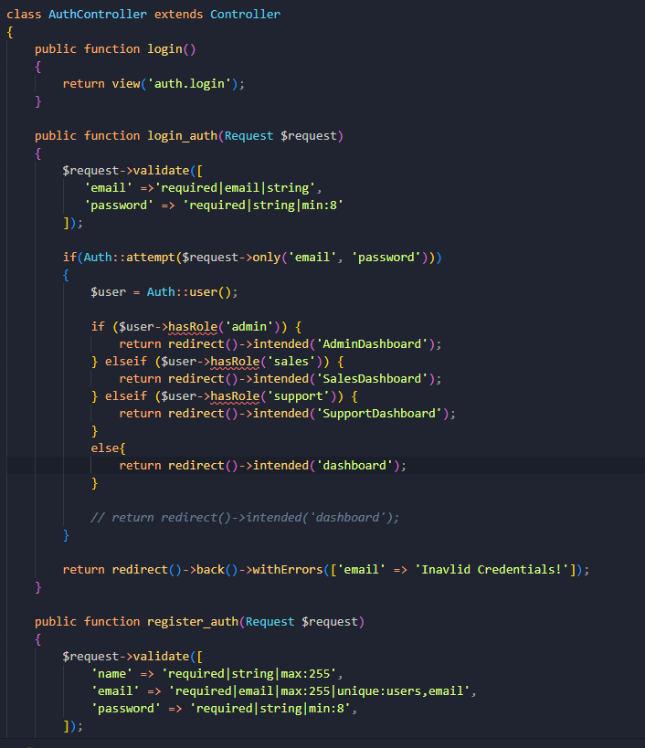

1. Role based System

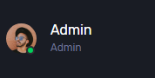  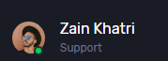

1. Develop register and login forms

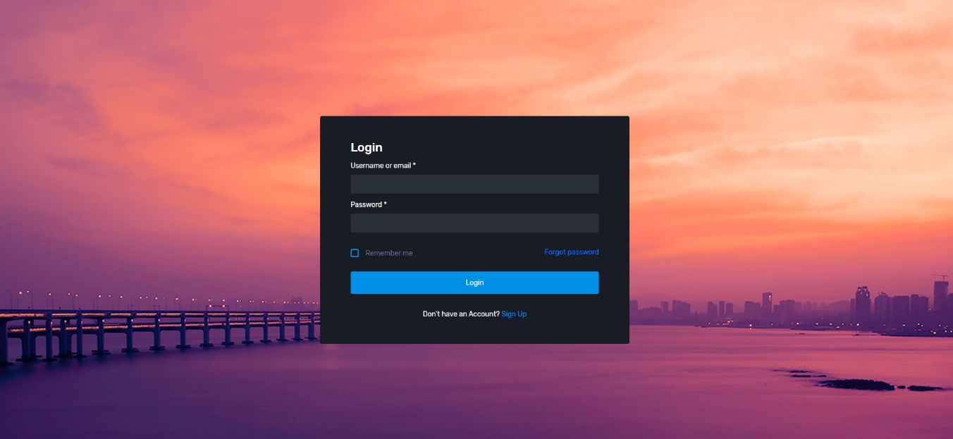

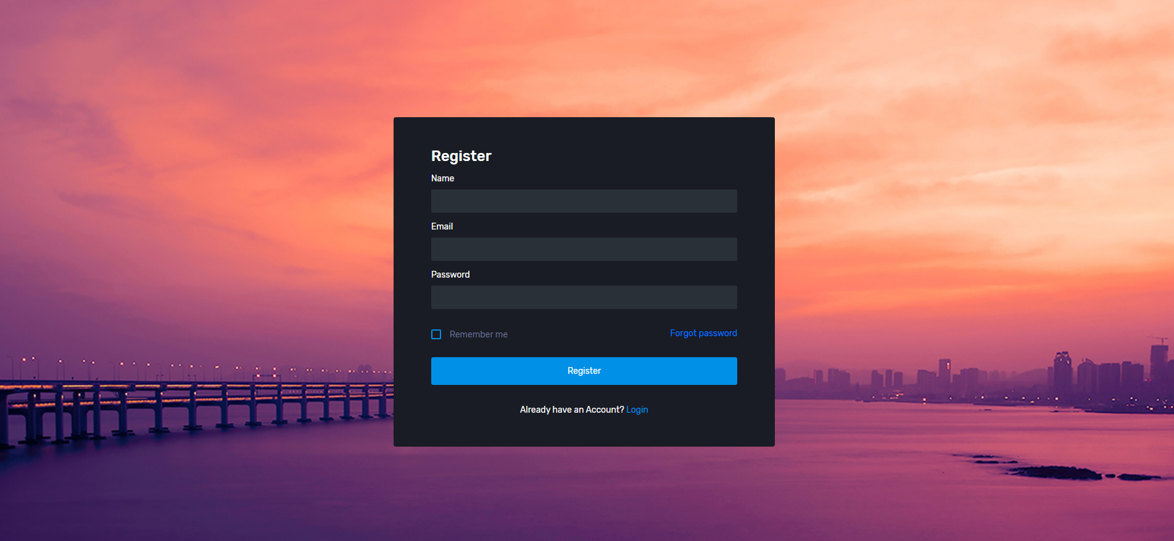

1. Profile management

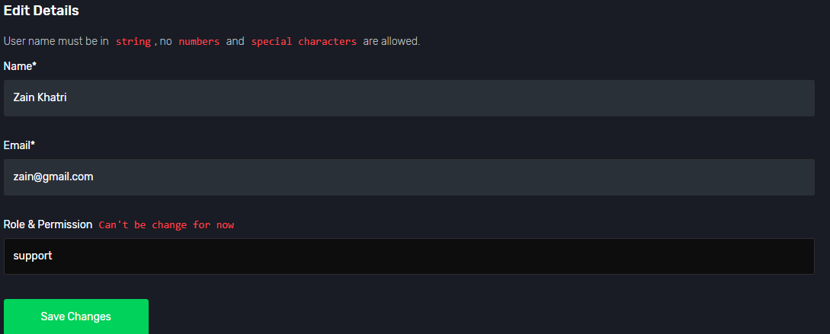

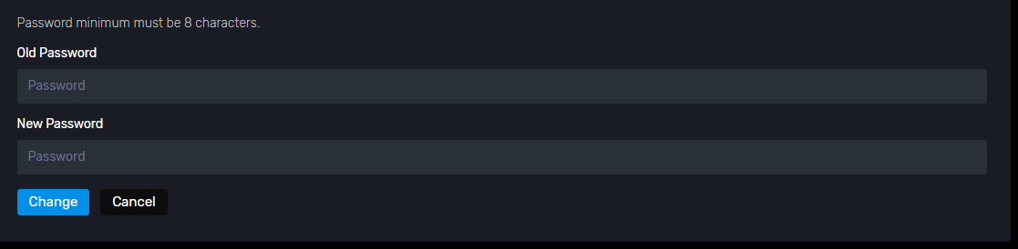

**Module 2 Customer Info Management:**

1. Customer information schema

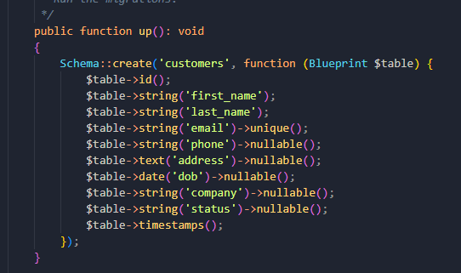

1. Add, delete, and edit customer info & customers view

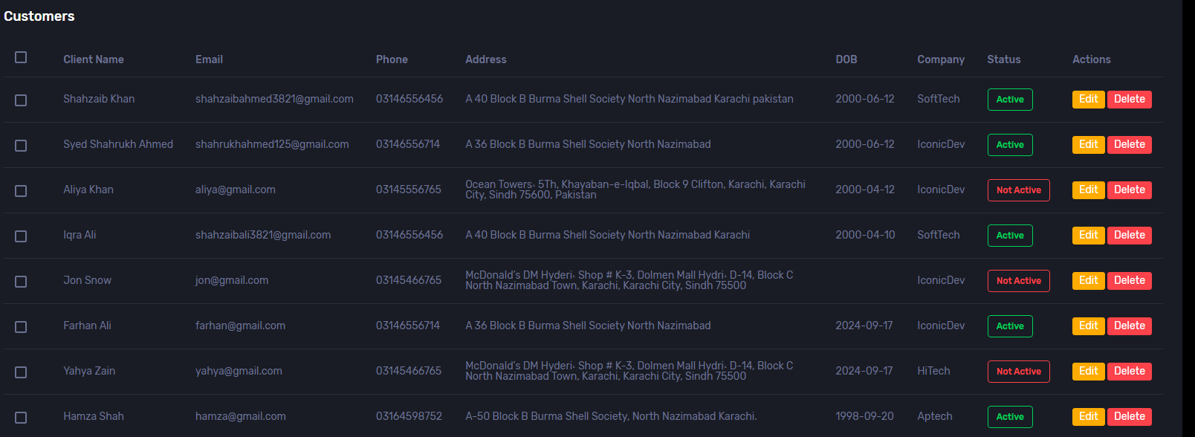

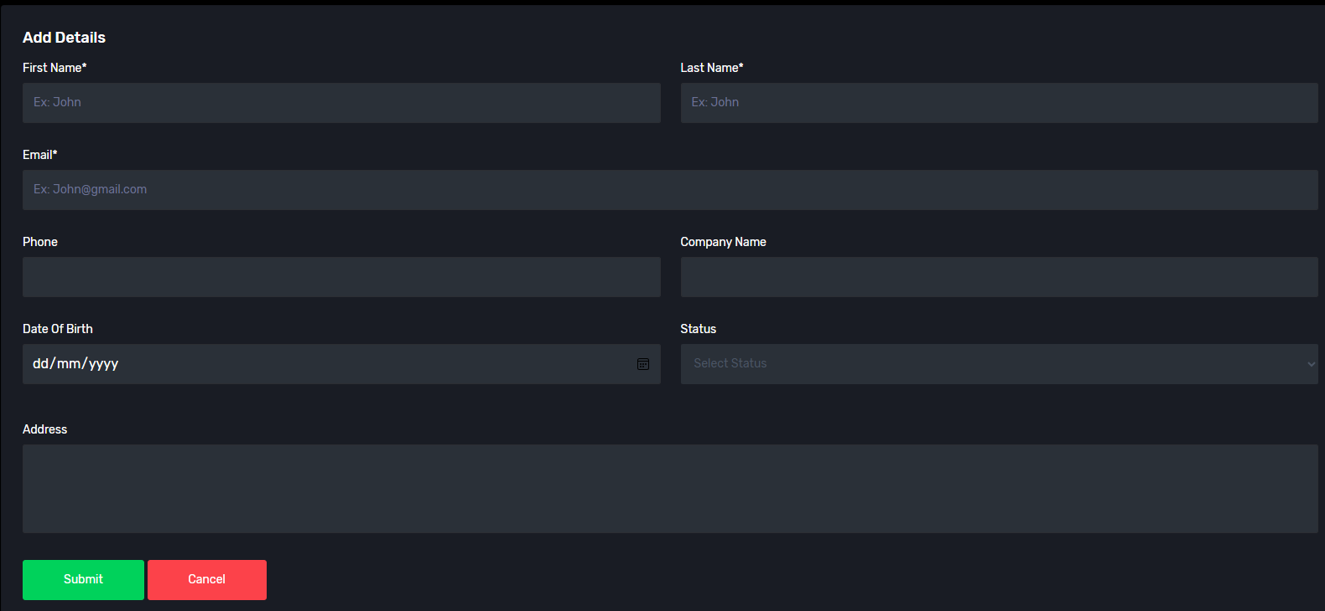

1. Filter and Search function

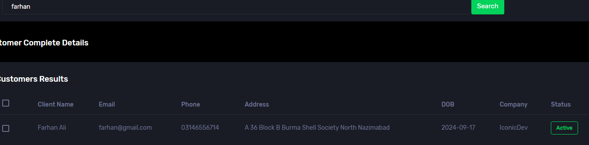

**Module 3 Interactions & Sales:**

1. Logging Interactions & viewing interactions

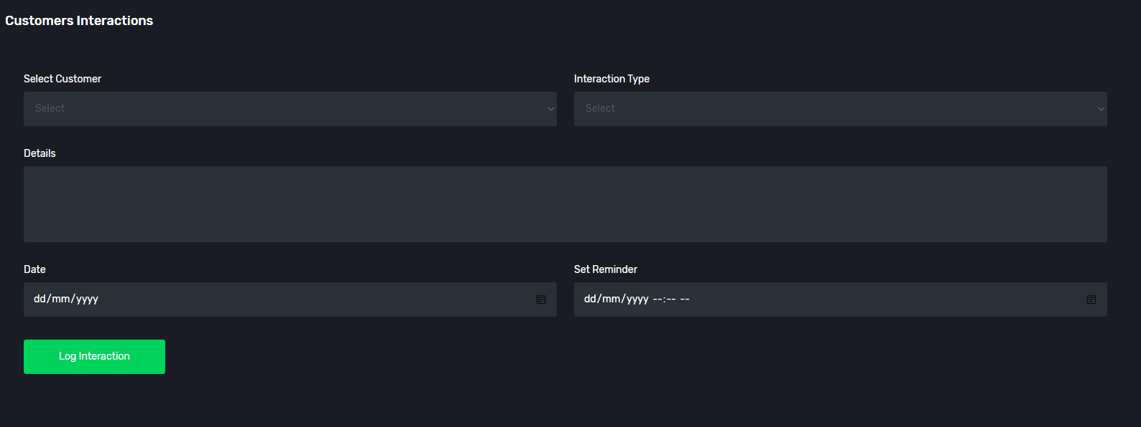

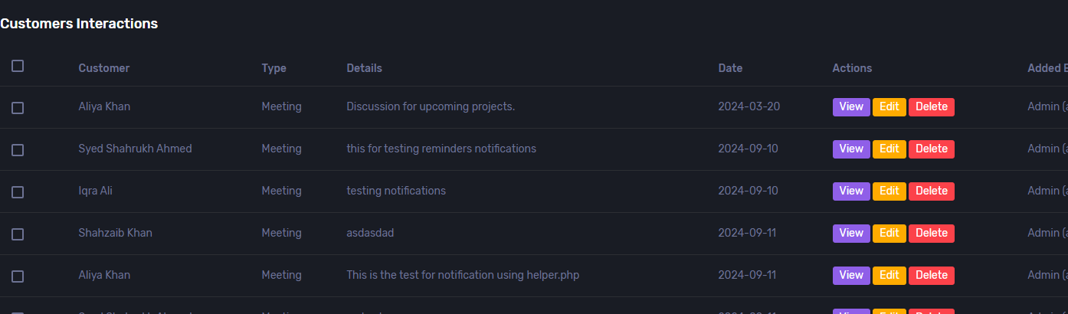

1. Sales Pipelines

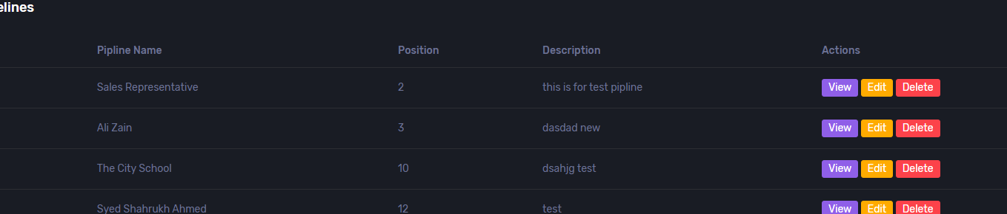

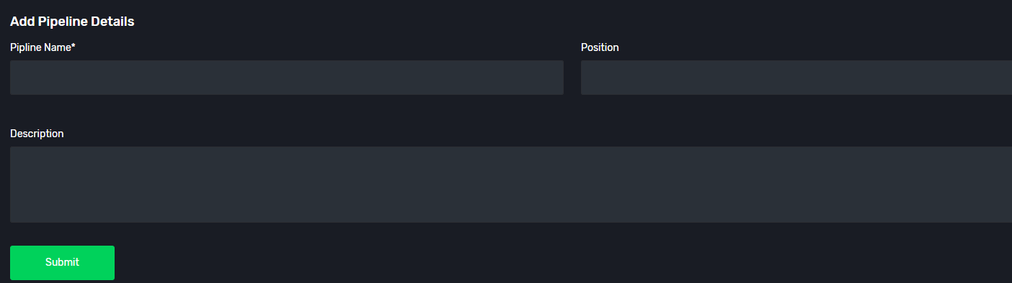

1. Reminders

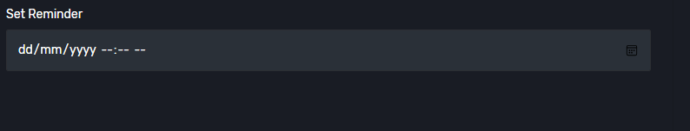

**Module 4 Reporting & Analytic:**

1. Reporting functionality & Sales Performance Analaytics

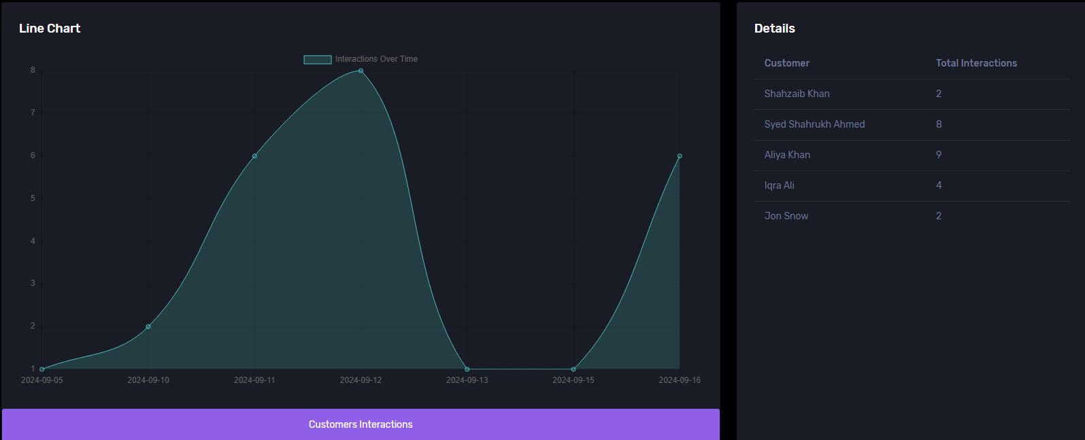

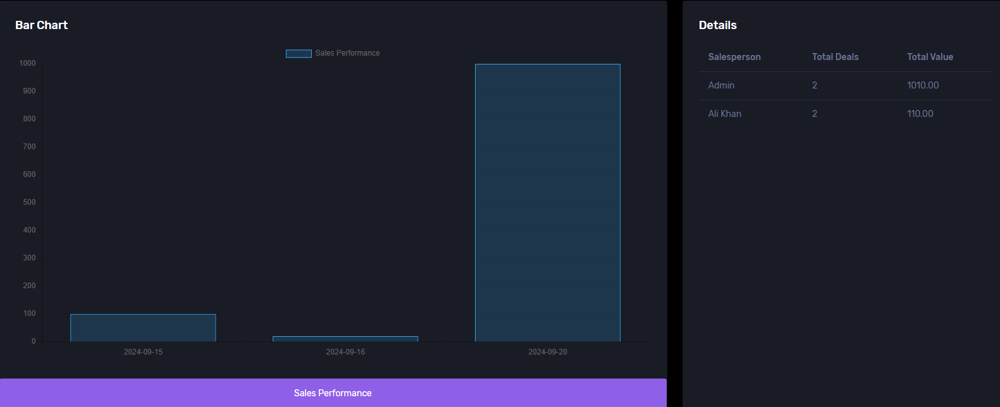

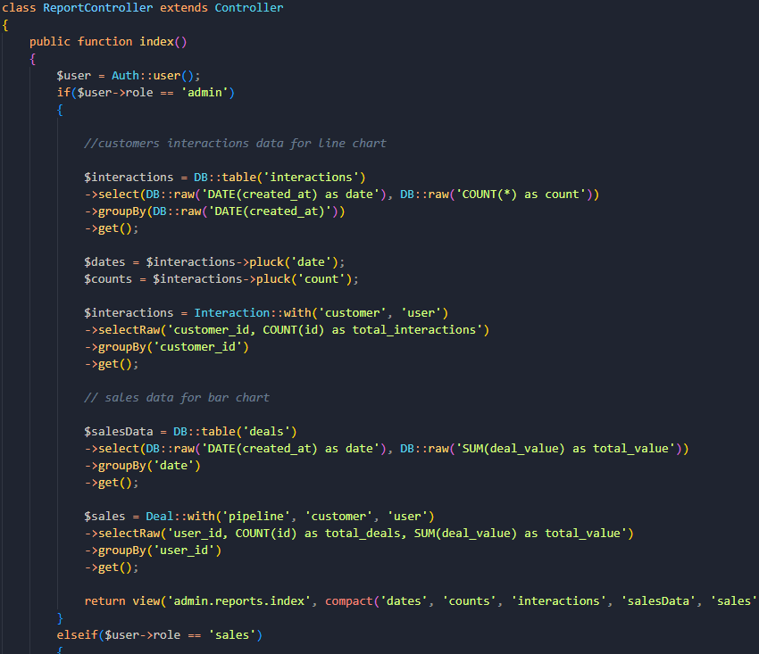

1. Customized Dashboard

